PRESIDENT’S OFFICE
REGIONAL ADMINISTRATION AND LOCAL GOVERNMENT
LONGIDO DISTRICTEXAMINATION SYNDICATE
FORM TWO PRE-MOCK EXAMINATION
HISTORY
TIME; 2; 30HOURS
INSTRUCTIONS
- This paper consist of three sections A,B,and c
- Answer all question in section A,B and two questions from section C
- All writing must be in blue or black ink

SECTION A
- For each of the following items choose the best answer from the given alternatives ;
- In which stage of evolution of man did agriculture and domestication involve?
- Iron Age
- Middle stone Age
- Late stone Age
- Early stone Age
- Gao was a trading center which developed into a large empire known as ;
- Soghai
- Asante
- Mali
- Ghana
- In evolution of man the systematic tool maker was ;
- Zinjantropus
- Australopithecines
- Homo-Habils
- Homosapiens
- The East Africa socities that developed clan organization based on matrilineal system were ;
- Makonde,makua,kamba,kikuyu and Yao
- Sandawe tindiga, makua ,Hadzabe and Haya
- Chagga ,Gogo,Sukuma ,Sandawe,and Yao
- Yao ,makonde ,Hehe,Sambaa and Luo
- Among the evidence of the earliest commercial contacts between East Africa ,middle and Far East as far back as 200B.C
- Existance of large Asia shops along the coastal area
- The periplus of the Erythrean Sea written by Greek Trader
- Existance of Arabicwords in Swahili language
- Growth of towns along the coastal area
- Homo-sapiens lived in one of the following periods ;
- Early stone Age
- Iron Age
- Late stone Age
- Middle stone Age
- The golden stool was a symbol of unity in the kingdom of ;
- Mali
- Soghai
- Ghana
- Asante
- Which one of the following factors led to the decline of soghai Empire
- Almoravids attack
- Moroccan invasion
- Attack from turegs
- Resistence from Portuguese
- The system of land ownership in Buhayawas known as ;
- Ubughabire
- Umwinyi
- Nyarubanja
- Busulo

- The evolution theory explains about;
- The survival of archiology remains
- The process of accumulating precious
- The origin of man using scientific approach
- The creation of man which is found in holy Books
- Match the items in list A with those of list b by writing the correct letter below the corresponding question number in the table provided
LIST A
- Audio-visual source of History
- Valuable commodities gathered by Asia from Africa
- 1500AD
- Time line ,time chsrt,and family tree
- The theory proposed by Charles Darwin
- Ugweno,Karagwe ,and Engaruka
- The Great zulu warror who Established zulu Empire
- Fall of the jesus
- Vasco Da Gama reached the coast of East Africa
- It stimulated the rise of Ghana mali,and soghai empire

LIST B
- Shaka
- Nyarubanja
- Iron site in East Africa
- Iron site in west Africa
- Evolution of man
- Determine historical sites
- 1698
- Emergence of ntemi system orgsnisation
- Ivory ,slave ,and gold
- Film and television
- 1498
- 1492
- 200B.C
- Trans-saharan tade
3(a) In space provided write TRUE if the statement is correct and FALSE if the statement is not correct
- Permanent Agriculture was practiced in arid and semi arid region…………
- Manikongo was founder of Ghana empire …………
- The Anglo-Boer war was fought between the British and Boer in 1899 and 1902……….
- Moroe and Nok were the major Iron site……..
- The Yao ,Nyamwezi and Kamba were not participants of longdistance trade ……
- Tanganyika got independence earlier than Kenya and Uganda ………
- Olduvai Gorge is historical sites in kondoa………..
- Mixed farming implies keeping animals and crop cultivation………
- Periplus of the erythrean sea means the discoveries made by Arab traders ……
- A century is period of one hundred years ……..
3(b) Write the missing historical facts
- The leader of zulu empire was known as …………………….
- Rusinga island and nsongezi are both historical sites found in ……………
- There are two theories of evolution of man and which are …………………….and ………………
- …………………is the first mode of production in which major means of production are
- owned and shared by all members of the community…………
- The exchange of goods among ppeolpe living in the same geographical area during pre-colonial era was ……………
4(a) Briefly explain the following terms
- Boer Trek
- Communalism
- Mansa musa
- Slavery
- Barter syste

4(b) Study this sketch map which shows trade routes during the 16th century and then answer the question which follows
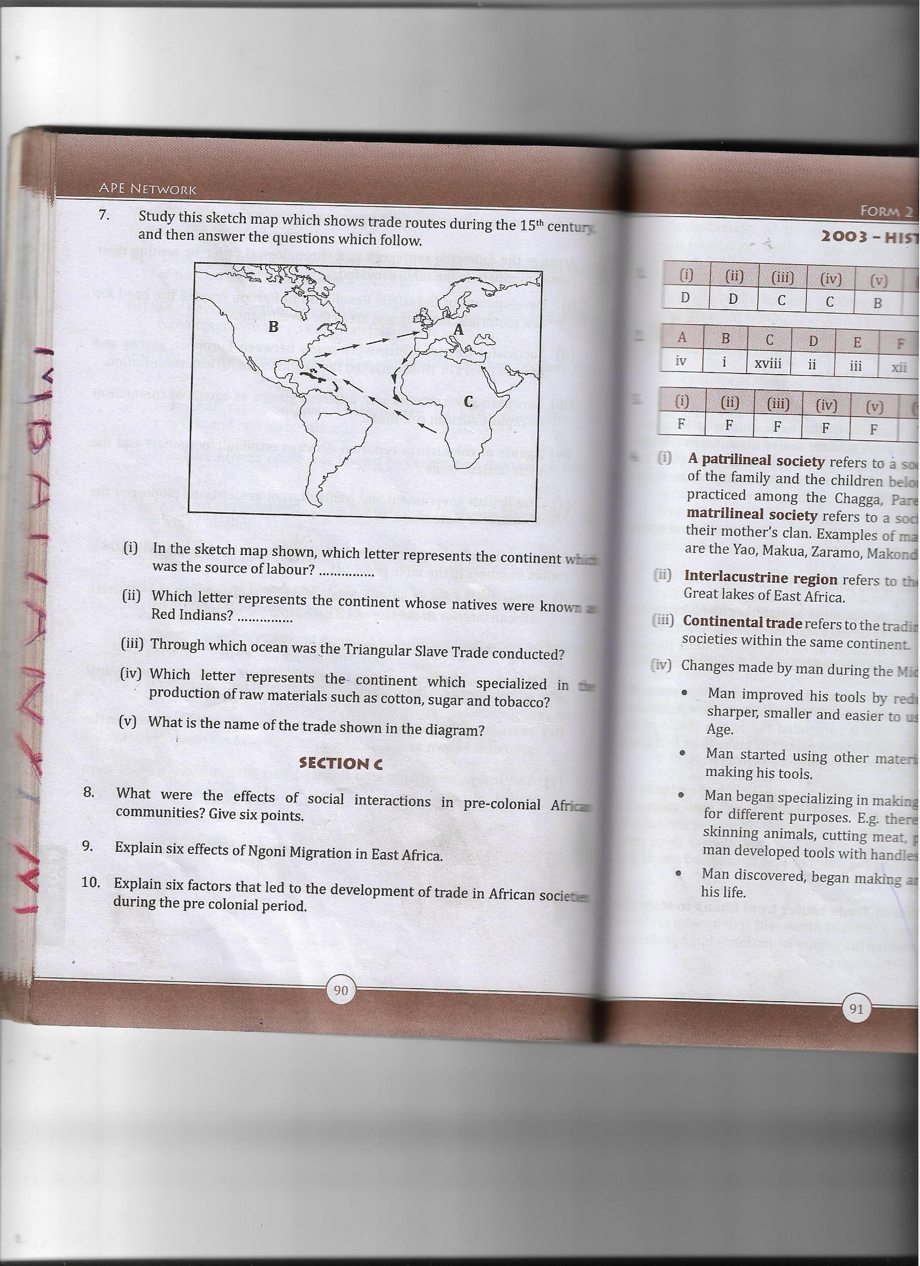
- In the sketch map shown which letter represents the continents which was the source of labour ……………..
- Which letter represents the continent whose natives were known as Red Indians ………
- Through which ocean was the triangular slave trade conducted ?
- Which letter represents the continent which specialized in the production of raw material such as cotton ,sugar ,and tobacco?
- What is the name of trade in the diagram?

SECTION C
Answer only two questions
5.Explain the four stages of evolution theory on the origin of man as proposed by Charles Darwin
6.Write an essay on factors of state formation using the following guideline s
- What is state?
- Three examples of state in East Africa
- Four factors for state formation
- Conclusion
7.Write short essay on ngoni migration under the following guidelines
- Meaning
- Participants
- Causes
- Effects
- Conclusion
8.Briefly explain five effect of iron technology discovery in most Africa socties.

